Cider Cottage at Woodhill Manor
Accessibility Statement
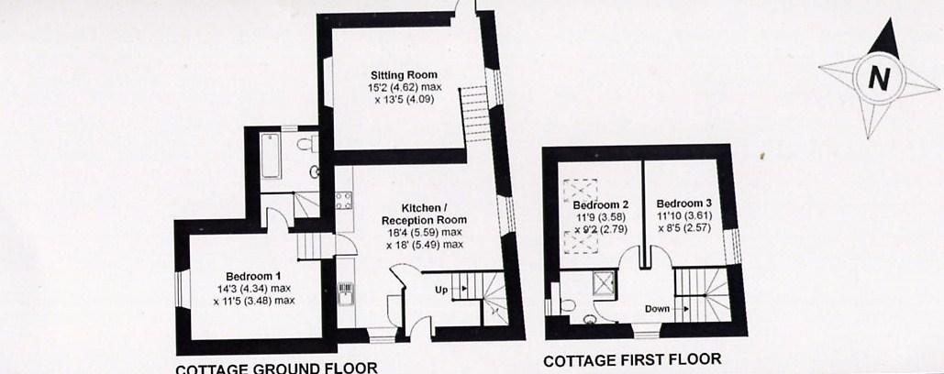

Cider Cottage was built well over 100 years ago and is not ideally suited to those with severe mobility problems, but those with less limiting conditions may be accommodated.

Cider Cottage is a very short walk along a gravel drive from the parking area, but guests are welcome to bring their car up to the front door whilst they unload their luggage or drop off passengers.

The front door is 1.085m in width and entered on the level.

There is an open plan kitchen dining room including an extra seating area on the same level. This area then leads to ;

- Lounge area on the lower ground floor. Access is down 8 steps with access to the back door which is 1.11m width; there are two granite steps down into the garden from the lounge.

- Master bedroom. Access is down 5 steps and a further 3 steps lead from here into the en-suite bathroom. The bathroom floor is tiled and the bath is low level.

- First floor accommodation. 12 steps lead to the upstairs accommodation comprising landing, 2 bedrooms and shower room. There is a very small step into the shower < 5cms and an opening of approximately 45cm. The floor is a lino type covering.

- All stairs are wooden and apart from the master bedroom which is carpeted the floors in Cider Cottage are wooden with rugs in the living areas, landing and other bedrooms.

All internal staircases have handrails or stair posts.

The garden can also be accessed from outside via a five bar gate on the level. In addition a steeply sloping grass path leads down at the far right of the building.

